Configuration Guide
Project PJT03222: Electric PolyPase De-Registration Follow-up Action
November 2014 Release

Document Information
Document Purpose | Electric Polyphase De-registration Follow Up Action Configuration
Document Owner | Legodile Kwapa
Business Owner
File Name(s) | PJT03222.Electric.Polyphase.Meters.Configuration.Document.Deregistration.Followup.Action.docx
Stored at | SharePoint: Smart Grid Enablement  SGE Documents Release 4 Complex Billing   Release R4a Work in Progress Execute Configuration Document AMI Electric Polyphase

Revision History
Version | Date | Author | Comments
0.1 | 9/17/2014 | Legodile Kwapa | Initial Creation

Contents
Document Information 2
Revision History 2
1.1.1 De-registration Follow up Action 4

PROJECT: SE – De-registration Follow-up Action Config

1.1.1 De-registration Follow up Action

Type: Configuration

Logical Component: N/A

Object:

Name:

Solution Manager Sub-Process Path: | Component -  View –  Object Subtype –
Document Name:
Created By: | Legodile Kwapa |  | Date Created: | 9/18/2014
Change History:
Support Ticket Number (post go-live) | Transport Number | Changed By: | Description of Change: | Change Date:
N/A

Configuration Logic:

Release 4a the key business requirements centered around the semi-automated provisioning, de-registration and de-provision of both single and poly phase electric AMI meters. A follow-up action for Acquisition lots has been added, in order to achieve the goal of automatically de-registering all meters tested in the lot.

Add Function Module : to the follow up action for Usage decision for Acquisition lots.

Transaction: SPRO
Node: Quality Management

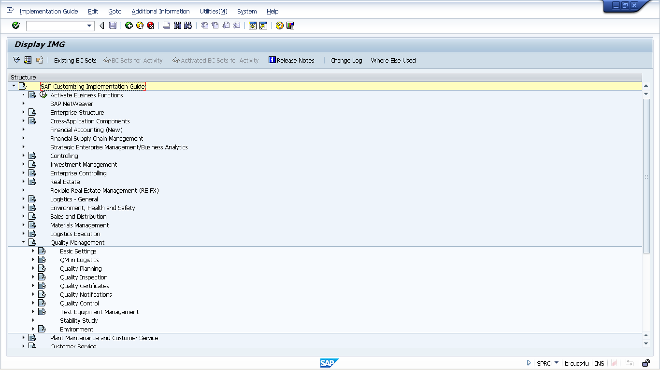

Drill Down to Quality Inspection Node

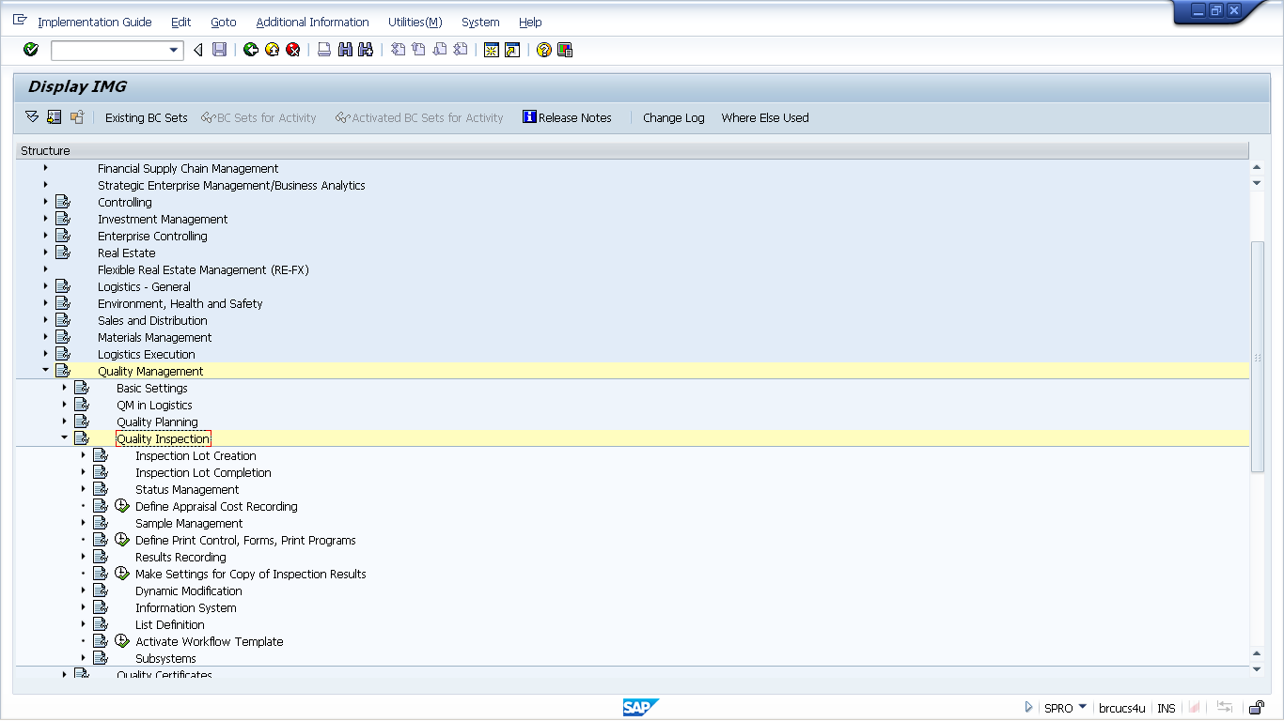

Drill Down to Inspection Lot Completion Node

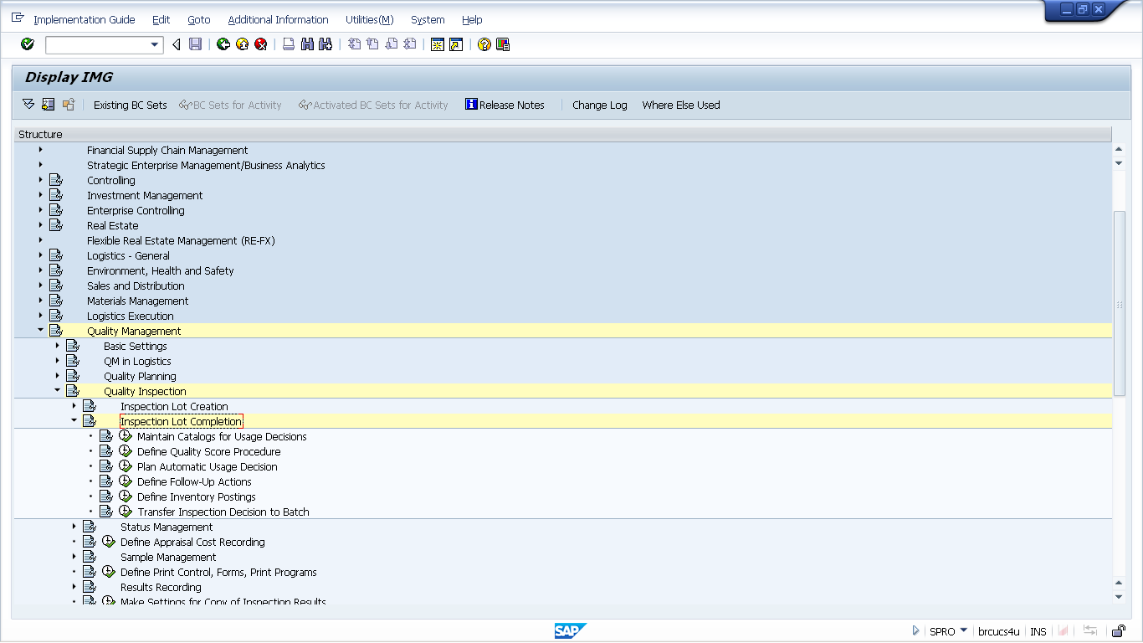

Drill Down to IMG Activity : Define Follow-Up Actions

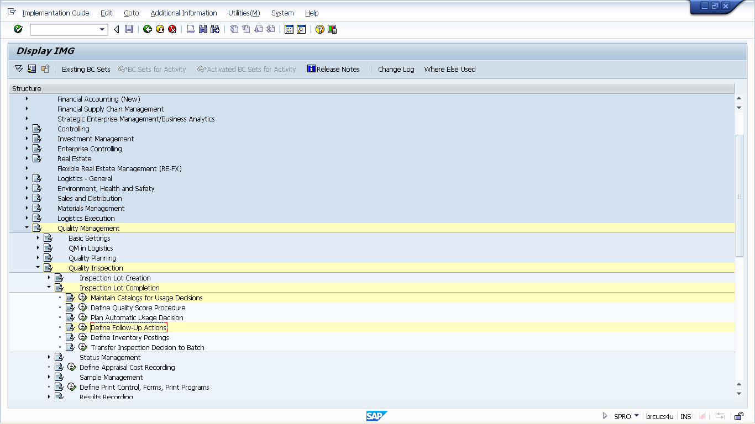

Choose activity Follow-Up Actions

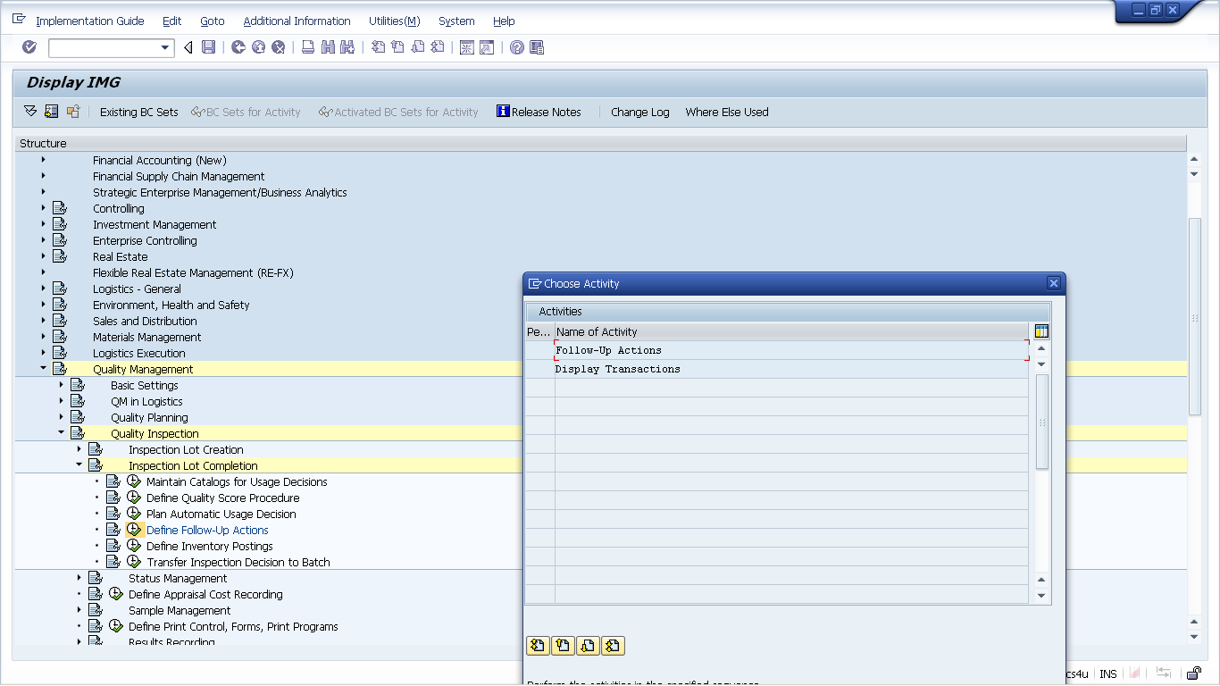

Select Follow-Up Actions LQM2 and double click on Function modules

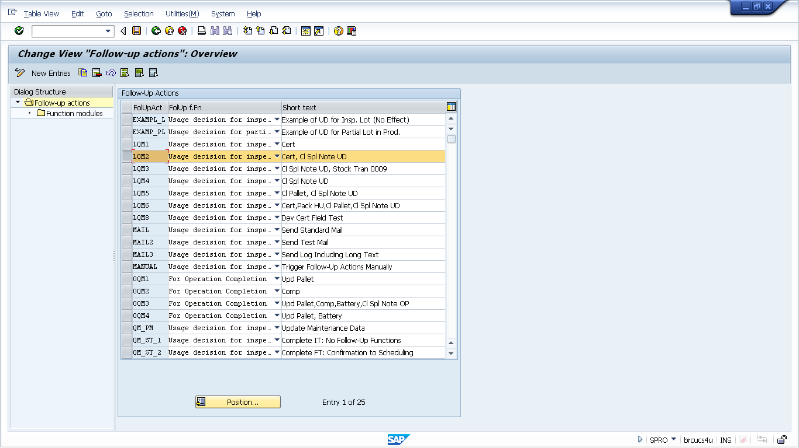

Add the new Function Module ZDM_DEVICE_LOAD_CONFIG

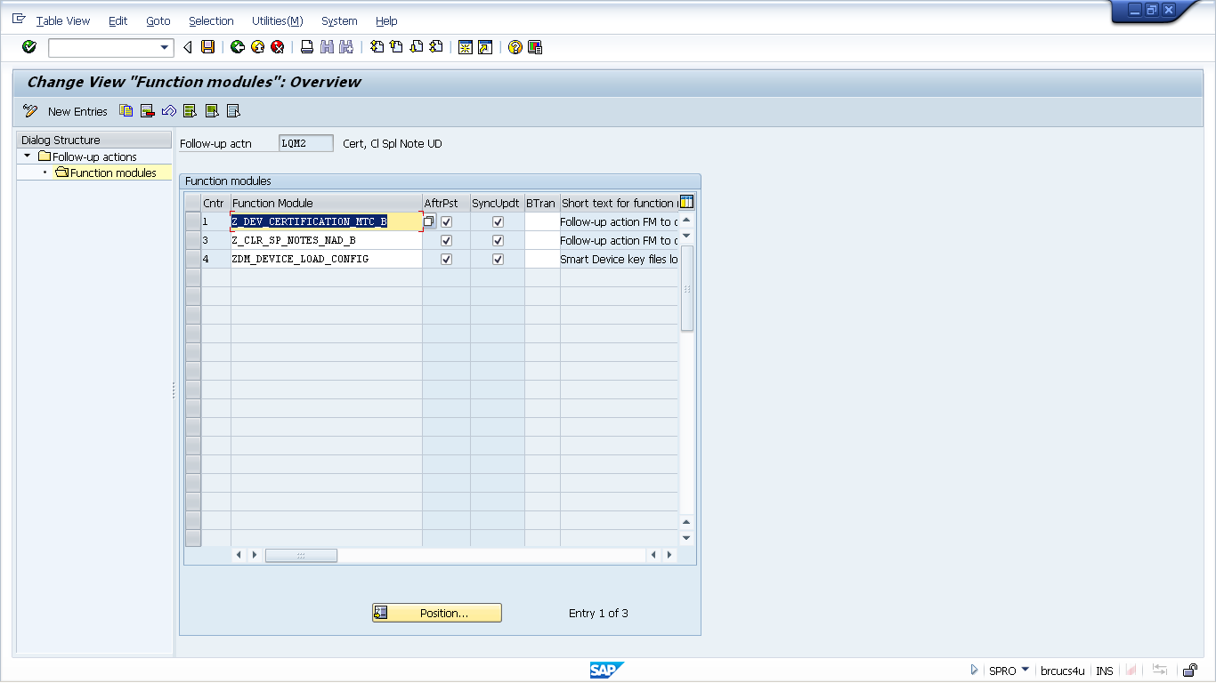

In the next few steps the function module is assigned to the desired Usage Decision Codes.

Drill Down to IMG Activity : Maintain Catalogs for Usage Decisions

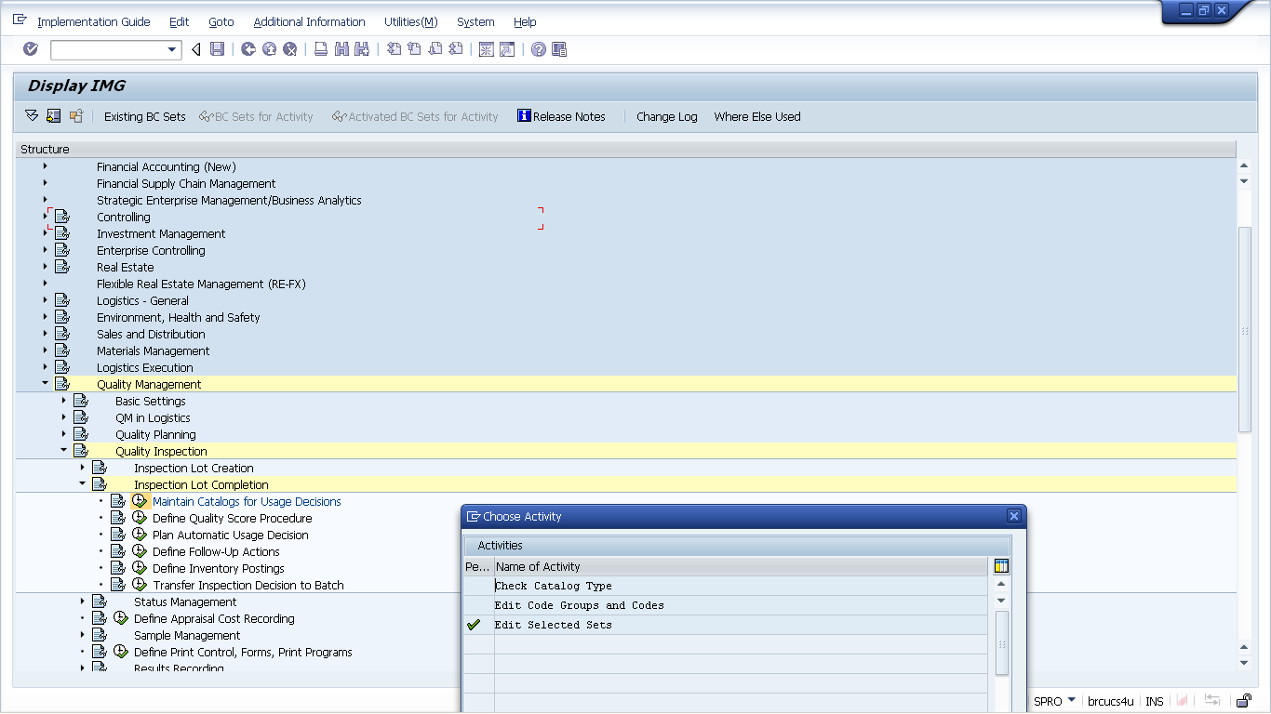

For the Edit Selected Set: Initial Screen
Catalog = 3
Plant = 0941
Selected set = ZNEWACQ

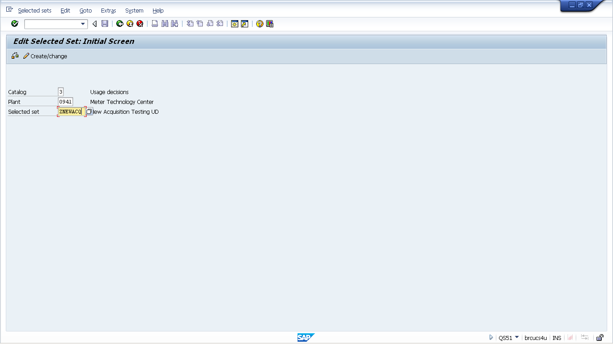

Select the ZNEWACQ line item and double click on Selected Set Codes

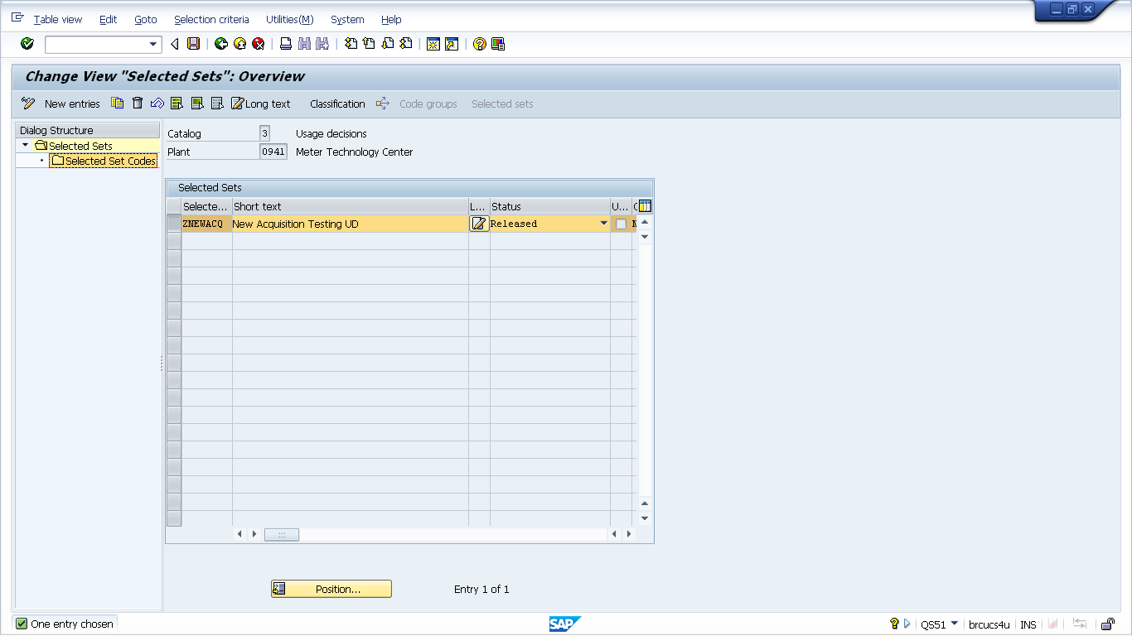

Verify that Follow up action : LQM2 is assigned to
Code Group: ZNEWACQ
Codes: AOK, POK, TRS

